**TITLE OF THE PROJECT**

*COVID-19 ONLINE NEWS PORTAL*

**Project Report**

*Submitted in fulfilment for the J Component of ITA1007 – Web Development*

**CAL Course**

***In***

**BCA**

*By*

**<KALAIPRIYA.A> (19BCA0007)**

**<ANUSRI.A> (19BCA0008)**

*Under the guidance of*

**DR. DEEPA.N**

**SITE**



**School of Information Technology and Engineering**

Fall Semester 2020-21

**TABLE OF CONTENTS**

|  |  |  |
| --- | --- | --- |
| **CHAPTER NO.** | **TITLE** | **PAGE NO.** |
|  | **ABSTRACT** | 03 |
|  | **INTRODUCTION** | 03 |
|  | **PROBLEM STATEMENT** | 04 |
|  | **SYSTEM DESIGN** | 05 |
|  | **SYSTEM SOFTWARE REQUIREMENTS** | 06 |
|  | **IMPLEMENTATION** | 07 |
|  | **SORCE CODE** | 08 |
|  | **TEST RESULTS** | 32 |
|  | **CONCLUSION** | 37 |

1. **ABSTRACT:**

Coronaviruses are enveloped non-segmented positive-sense RNA viruses belonging to the family Coronaviridae. The human coronavirus infections are mild, the epidemics of the two β-coronaviruses, severe acute respiratory syndrome coronavirus (SARS-CoV) and Middle East respiratory syndrome coronavirus (MERS-CoV) have caused more than ten thousand cumulative cases in the past two decades. There is a new public health crises threatening the world with the emergence and spread of 2019 novel coronavirus (2019-nCoV). The virus originated in bats and was transmitted to humans through yet unknown intermediary animals in Wuhan, Hubei province in China during the month of December 2019.

1. **INTRODUCTION:**

The corona virus is a most dangerous virus in our world now the time also it doesn’t cure. It’s affected millions of people in the world. So, our topic is covid-19 News Portal. It is totally about on Corona Virus (most dangerous disease). This system is helps to known the how many peoples are affected by Corona Virus and we can able to watch the live updates about corona virus. In this system we are updated the Worldometer. It’s easy to refer calculation about how many peoples were affected. Then people can able to know the prevention methods and also its help to cure the virus. And also we are added the fund collection method. Some peoples are wanted to donate some money to affected peoples so that we could able to added this method in this system.

1. **PROJECTSTATEMENT**

**Project Topic:** Online Covid-19 News Portal

**What is Online Covid-19 News Portal?**

This projects develops a system which is about the Covid-19 virus. **Corona virus disease 2019** (**COVID-19**) is a [contagious](https://en.wikipedia.org/wiki/Infection#Contagiousness) [respiratory](https://en.wikipedia.org/wiki/Respiratory_disease) and [vascular](https://en.wikipedia.org/wiki/Vascular_disease) (blood vessel) [disease](https://en.wikipedia.org/wiki/Disease). It is caused by becoming infected with [severe acute respiratory syndrome corona virus 2](https://en.wikipedia.org/wiki/Severe_acute_respiratory_syndrome_coronavirus_2) (SARS-CoV-2), which is a specific type of [corona virus](https://en.wikipedia.org/wiki/Coronavirus) and this is specifically based on Current Live Status about on Corona Virus.

**Objective:**

This project eliminates they need to search for different information regarding covid-19 in newspaper and other magazines. And also people doesn’t know how to protect themselves can see the prevention method and information regarding Covid1-9 in this website.

**The Main Purpose of Covid-19 Portal:**

* It has clear information regarding covid-19 and it also tells the Scientific terms of Covid-19 virus .Its origin is stated.
* All the prevention methods are clearly stated for the people. It also has a temperature check page where people can find out if they are safe or not.
* And also fund collection page where people can donate for infected people.

**For This Application, we will provide following capabilities:**

* Fund collection
* Temperature check
* Payment method
* Worldometer
* Prevention methods

1. **SYSTEM DESIGN**

**(A)ER- DIAGRAM:**

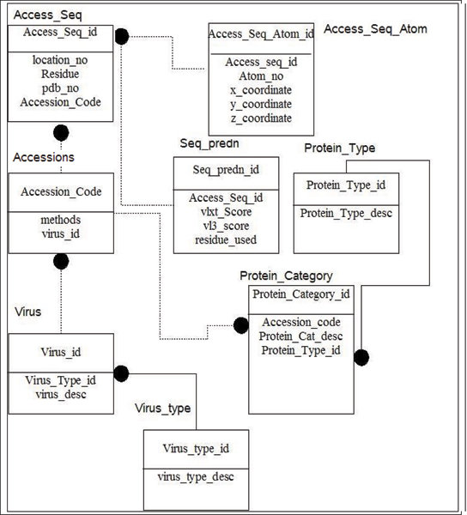

**(B)DATA FLOWDIAGRAM:**

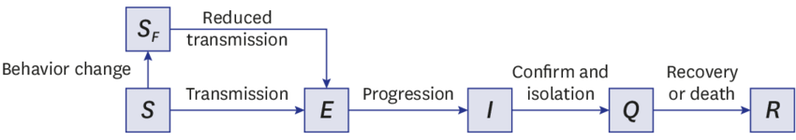

1. **SYSTEM REQUIREMENT SPECIFICATION:**

The project covid-19 news portal is developed to known the current updates of corona virus and this system is helps to collect the fund for affected peoples. Then this portal is also helps to check the temperature. Peoples can able to know the prevention method of corona virus.

**INTENDED USERS AND READING SUGGESTIONS:**

**This Software Requirements document is intended for:**

* **Administrator**: should have the basic Knowledge of computers and Visual Basic inorder to perform tasks.
* **User** who should have the basic Knowledge of computers and Visual Basic in order to perform tasks and who wishes to read about what this project can do.
* **Developers** who can view project’s abilities and can easily understand to add more features for future development.

**SCOPE**: This project is helpful to computerize the Covid-19 Live News, Fund Collection, Payments and Prevention method for each user.

**System Requirement:** The user must have an internet browser with latest HTML5 browser support. And Intel GUI graphics support.

**Front End**: Html, CSS, JavaScript

**Back End**: None

**Browser Information**: Google Chrome, Mozilla Firefox etc.

**System Requirement**: Windows oo7/8/10, MACOS (after Lion), Linux Ubuntu (14).

1. **IMPLEMENTATION:**

The development is made with action plan with our team. In my team only two members. We both are done our works with good coordination. We are strong to work in this project. we both discussed and separated a work with half page done and execute by one and other part done by the other.

**RECOURSES USED:**

**SOFTWARE (IDE):** MICROSOFT VISUAL STUDIO CODE

**SCRIPTING LANGUAGES**: HTML, CSS AND JAVASCRIPT

1. **SOURCE CODE:**

**MAIN FRAME**

<html>

<head>

<title>corona main</title>

</head>

<frameset rows="250,*">

<frame src="corona top frame.html"/>

<frameset cols="1700,*">

<frame src="corona center frame.html"/>

<frame src="corona right frame.html"/>

</frameset>

</html>

**TOP FRAME**

<html>

<head>

<title>corona virus top frame</title>

</head>

<b><center><font color="#fff44f" size="60">COVID</font><font color="red"size="60"> - 19 </font><font color="#fff44f"size="60"> NEWS </font><font color="red" size="60"> PORTAL </font></center><b>

<div id="TblCon">

<table class="Tbl">

<td>

<a href="https://www.who.int">

<img src="https://devpolicy.org/wp-content/uploads/2015/02/image13.png" alt="world health organization" style="width:100px">

</a>

</td>

<td>

<a href="https://www.worldometers.info/coronavirus/ " target="_blank">

<img src="https://www.worldometers.info/img/worldometers-logo.gif" target="_blank">

</a>

</td>

</tr>

</table>

<!-- Table End -->

</div>

<b><h1><font color="white">

<marquee behavior="scroll" direction="left" height="250"

scrollamount="10" scrolldelay="20""></h1></font></b>

<font color="#006b38ff">COVID</font><font color="#f2aa4cff">-19</font><font color="#fff44f"> PANDEMIC</font> | <font color="#006b38ff">STATE</font><font color="#f2aa4cff"> HELPLINE</font><font color="#fff44f">NUMBER</font><font color="#006b38ff">-0381-231-5879</font> | <font color="#f2aa4cff">PROCTECT</font><font color="#fff44f">YOURSELF</font><font color="#006b38ff"> WHILE </font><font color="#f2aa4cff">CARING </font><font color="#f2aa4cff">FOR </font><font color="#006b38ff">OTHERS.</font>

</marquee>

<style>

body

{

background-image:url("https://www.lefthudson.com/wp-content/uploads/2019/11/black-and-red-background-best-of-black-and-red-wallpapers-hd-wallpaper-cave-inspiration-of-black-and-red-background.png");

background-position:center;

background-size:cover;

background-repeat:no-repeat;

background-attachment:fixed;

}

</div>

</body>

</style>

</html>

**CENTRE FRAME**

<html>

<head>

<title>corona virus center</title>

<style>

h6{

position:fixed;

left:400px;

top:0px;

background:white;

margin:;

border: 8px solid red;

}

</style>

<style>

div{

position:fixed;

left:900px;

top:30px;

background:white;

margin:;

border: 8px solid red;

</style>

<style>

body

{

background-image:url("https://www.nationaljewish.org/NJH/media/img/stock/Coronavirus-COVID-19.jpg?ext=.jpg?width=378");

background-position:center;

background-size:cover;

background-repeat:no-repeat;

background-attachment:fixed;

}

</style>

<div><font face="calibri" color="red">

<img src="https://upload.wikimedia.org/wikipedia/commons/thumb/8/82/SARS-CoV-2_without_background.png/800px-SARS-CoV-2_without_background.png" width="400" height="200"/>

<br/><h1>CORONA VIRUS</h1>

<font face="calibri" size="5" color="black" ><b>Red</b> - Spike protein <br/><b>Grey</b> - Lipid bilayer envolope<br/><b>Yellow</b> - Envolope protien<br/><b>Orange</b> - Membrane protien<br/>

<font face="calibri" color="red"><b><h2>Virus Classification</h2></b></font>

<b>Realm</b>: Riboviria<br/>

<b>Kingdom</b>:Orthornavirae<br/>

<b>Phylum</b>: Pisuviricota<br/>

<b>Class</b>: Pisoniviricetes<br/>

<b>Order</b>: Nidovirales<br/>

<b>Family</b>: Coronaviridae<br/>

</font>

</div>

</font>

<body>

<h6><font size="5" face="calibri" color="red">

<img src="https://img.webmd.com/dtmcms/live/webmd/consumer_assets/site_images/article_thumbnails/news/2020/01_2020/coronavirus_1/1800x1200_coronavirus_1.jpg" width="400" height="200"/>

<br/>

<h2> CORONA VIRUS</h2>

<h3><font face="calibri" color="black">Coronaviruses are<br/>

a group of RNA viruses<br/>

that cause

diseases<br/>

in mammals

and birds.<br/>

In humans and birds,<br/>

they cause respiratory<br/>

tract infections<br/>

that can range from<br/>

mild to lethal.<br/>

covid 19 is a fever causing virus.<br/>

</h3></font>

</font></h6>

</body>

</html>

**Right frame**

<html>

<head>

<title>right frame</title>

</head>

<body bgcolor="black">

<style>

div{

height:40px;

width:240px;

padding:1px;

border:5px groove black;

margin:1px;

}

</style>

<style>

a{

text-decoration:none;

color:white;

font-color:red;

}

</style>

<div>

<br/>

<font color="red"><a href="originofcorona.html"target="_blank"><h2>ORIGIN OF CORONA</h2></a></font>

</div><br/><br/><br/>

<div>

<font color="red"><a href="temperaturecheck.html"target="_blank"><h2>TEMPERATURE CHECK</h2></a></font>

</div><br/><br/><br/>

<div>

<font color="red"><a href="preventionmethods.html"target="_blank"><h2>PREVENTION METHODS</h2></a></font>

</div><br/><br/><br/>

<div>

<font color="red"><a href="fund collection.html"target="_blank"><h2>FUND COLLECTION</h2></a></font>

</div><br/><br/><br/>

<img src="https://cdn.mos.cms.futurecdn.net/LwiKsyxF4xGLDKYqBVyFEL.jpg" align="middle" width="250" height="250"alt="corona"/>

</body>

</html>

**ORIGIN OF CORONA VIRUS**

<html>

<head>

<title>

originofcorona</title>

<style>

body

{

background-image:url("https://image.freepik.com/free-photo/smoke-abstract-background-light-pastel-colors_89245-89.jpg");

background-position:center;

background-size:cover;

background-repeat:no-repeat;

background-attachment:fixed;

}

</style>

<style>

a{

text-decoration:none;

}

</style>

</head>

<body >

<font face="Constantia" size="10">

<a href="corona main frame.html"target="_blank">HOME</a></font>

<center><b>

<font size="15" face="times new roman" color="red">ORIGIN OF CORONA VIRUS</font></b></center><br/><br/><br/><br/>

<p><font size="5" face="Constantia" color="voilet">

Coronaviruses are found in a diverse array of bat and bird species, which are believed to act as natural hosts. Molecular clock dating analyses of coronaviruses suggest that the most recent common ancestor of these viruses existed around 10,000 years ago. This relatively young age is in sharp contrast to the ancient evolutionary history of their putative natural hosts, which began diversifying tens of millions of years ago.

</font></p><img src="https://revistabionatura.com/images/2020.05.02.15-figure-1.jpg" align="middle" width="1000" height="500"alt="corona"/>

<p><font size="5" face="Constantia" color="green">Here, we attempted to resolve this discrepancy by applying more realistic evolutionary models that have previously revealed the ancient evolutionary history of other RNA viruses. By explicitly modeling variation in the strength of natural selection over time and thereby improving the modeling of substitution saturation,

we found that the time to the most recent ancestor common for all coronaviruses is likely far greater (millions of years) than the previously inferred range.</font></p>

<img src="https://ars.els-cdn.com/content/image/1-s2.0-S2090123220300540-gr2.jpg" align="middle" width="1000" height="500"alt="corona"/><br/>

<font size="5" face="Constantia" color="orange"><p>Recently at the end of 2019, Wuhan an emerging business hub of China experienced an outbreak of a novel coronavirus that killed more than eighteen hundred and infected over seventy thousand individuals within the first fifty days of the epidemic. This virus was reported to be a member of the β group of coronaviruses. The novel virus was named as Wuhan coronavirus or 2019 novel coronavirus (2019-nCov) by the Chinese researchers. The International Committee on Taxonomy of Viruses (ICTV) named the virus as SARS-CoV-2 and the disease as COVID-19</p>

</font><font size="5" face="Constantia" color="red"><p>The key reservoirs and mode of transmission of coronaviruses (suspected reservoirs of SARS-CoV-2 are red encircled); only α and β coronaviruses have the ability to infect humans, the consumption of infected animal as a source of food is the major cause of animal to human transmission of the virus and due to close contact with an infected person, the virus is further transmitted to healthy persons. Dotted black arrow shows the possibility of viral transfer from bat whereas the solid black arrow represent the confirmed transfer.</p>

</font><img src="https://ars.els-cdn.com/content/image/1-s2.0-S2090123220300540-gr3.jpg"align="middle" width="1000" height="500"alt="corona"/><br/>

</font><font size="5" face="Constantia" color="voilet"><p>

The life cycle of SARS-CoV-2 in host cells; begins its life cycle when S protein binds to the cellular receptor ACE2. After receptor binding, the conformation change in the S protein facilitates viral envelope fusion with the cell membrane through the endosomal pathway. Then SARS-CoV-2 releases RNA into the host cell. Genome RNA is translated into viral replicase polyproteins pp1a and 1ab, which are then cleaved into small products by viral proteinases. The polymerase produces a series of subgenomic mRNAs by discontinuous transcription and finally translated into relevant viral proteins. Viral proteins and genome RNA are subsequently assembled into virions in the ER and Golgi and then transported via vesicles and released out of the cell. ACE2, angiotensin-converting enzyme 2; ER, endoplasmic reticulum; ERGIC, ER–Golgi intermediate compartment.<p>

</font><img src="https://ars.els-cdn.com/content/image/1-s2.0-S2090123220300540-gr4.jpg" align="middle" width="1000" height="500"alt="corona"/><br/>

<font size="5" face="Constantia" color="orange"><p> Betacoronaviruses genome organization; The Betacoronavirus for human (SARS-CoV-2, SARS-CoV and MERS-CoV) genome comprises of the 5′-untranslated region (5′-UTR), open reading frame (orf) 1a/b (green box) encoding non-structural proteins (nsp) for replication, structural proteins including spike (blue box), envelop (maroon box), membrane (pink box), and nucleocapsid (cyan box) proteins, accessory proteins (light gray boxes) such as orf 3, 6, 7a, 7b, 8 and 9b in the SARS-CoV-2 genome, and the 3′-untranslated region (3′-UTR). The doted underlined in red are the protein which shows key variation between SARS-CoV-2 and SARS-CoV. The length of nsps and orfs are not drawn in scale.</p></font>

</body></html>

**TEMPERATURE CHECK**

<html>

<head>

<title>temperaturecheck</title>

<style>

body

{

background-image:url("https://media.npr.org/assets/img/2020/05/08/gettyimages-1216086806_custom-05446e3efef764aee048a03b373fa83da8c24db8.jpg");

background-position:center;

background-size:cover;

background-repeat:no-repeat;

background-attachment:fixed;

}

</style>

<style>

a{

text-decoration:none;

}

</style>

<style>

h1{

height:40px;

width:1200px;

padding:1px;

border:5px groove white;

margin:1px;

font-color:white;

background-color:black;

}

</style>

<center>

<h1><font color="white">BODY TEMPERATURE TO CHECK CORONA POSSIBILITIES</font></h1></center>

<br/>

<br/>

<br/>

<script type="text/javascript">

var x;

x=window.prompt("Enter your body temperature in fahrenheit","0");

x=parseInt(x);

if(x<98)

{

document.write(" HELLA ! YOUR NORMAL.....BE SAFE");

}

else if(x<100)

{

document.write(" BE ALRET !! STAY AWAY FROM PEOPLE, UNDERTAKE SAFETY MEASURES!");

}

else

{

document.write(" PLEASE ! BE IN QUARANTINE AND VISIT YOUR NEARBY DOCTOR ");

}

</script>

</head>

<body>

<h2>

<a href="corona main frame.html"target="_blank">HOME</a></h2>

</body>

</html>

**PREVENTION METHODS**

<html>

<head>

<title>preventionmethods</title>

</head>

<style>

body

{

background-image:url("https://thumbs.dreamstime.com/b/new-surgical-masks-coronavirus-prevention-white-background-healthcare-concept-medical-tools-179334561.jpg");

background-position:center;

background-size:cover;

background-repeat:no-repeat;

background-attachment:fixed;

}

</style>

<style>

a{

text-decoration:none;

}

</style>

<body>

<font face="Constantia" size="10">

<a href="corona main frame.html"target="_blank">HOME</a></font>

<center>

<b><font face="Constantia" size="10" color="blue">PREVENTION METHODS</font></b><br/></center><br/><br/>

<br/>

<br/><br/><br/><br/></b>

<b><font face="Constantia" size="10" color="red">Follow the guidelines to help protect yourself from contracting and transmitting SARS-CoV-2</font></b><br/><br/><br/><br/>

<img src="https://i0.wp.com/post.medicalnewstoday.com/wp-content/uploads/sites/3/2020/03/Tips-to-prevent-coronavirus-transmission_ver4-2-scaled.jpg?w=1155&h=5376" align="middle" width="400" height="700"alt="corona"/><br/>

<b><font face="Constantia" size="10" color="blue">1. Wash your hands frequently and carefully</font></b><br/><br/><br/><br/>

<font face="Constantia" size="5">Use warm water and soap and rub your hands for at least 20 seconds. Work the lather to your wrists, between your fingers, and under your fingernails.<br/>

You can also use an antibacterial and antiviral soap.<br/>

Use hand sanitizer when you cannot wash your hands properly. Rewash your hands several times a day, especially after touching anything, including your phone or laptop.<br/></font>

<br/>

<b><font face="Constantia" size="10" color="blue">2. Avoid touching your face</font></b><br/><br/><br/><br/>

<font face="Constantia" size="5">SARS-CoV-2 can live on some surfaces for up to 72 hours.<br/>

You can get the virus on your hands if you touch a surface like:<br/><br/><br/><br/>

gas pump handle<br/>

your cell phone<br/>

doorknob<br/><br/><br/>

Avoid touching any part of your face or head, including your mouth, nose, and eyes. Also avoid biting your fingernails.<br/>

This can give SARS-CoV-2 a chance to go from your hands into your body.<br/></font><br/><br/><br/><br/>

<b><font face="Constantia" size="10" color="blue">3. Stop shaking hands and hugging people</font></b><br/><br/><br/>

<font face="Constantia" size="5">Similarly, avoid touching other people. Skin-to-skin contact can transmit SARS-CoV-2 from one person to another.<br/></font><br/><br/>

<b><font face="Constantia" size="10" color="blue">4. Don’t share personal items</font></b><br/><br/><br/><br/><br/>

<b><font face="Constantia" size="5" color="red">Do not share personal items like:</font></b><br/><br/><br/>

<font face="Constantia" size="5">

phones<br/>

makeup<br/>

combs<br/>

It’s also important not to share eating utensils and straws. Teach children to recognize their reusable cup, straw, and other dishes for their own use only.<br/></font>

<br/><br/><br/><br/><b><font face="Constantia" size="10" color="blue">5. Cover your mouth and nose when you sneeze.</font></b><br/><br/><br/><br/><br/>

<font face="Constantia" size="5">

SARS-CoV-2 is found in high amounts in the nose and mouth. This means it can be carried by air droplets to other people when you cough, sneeze, or talk.<br/>

It can also land on hard surfaces and stay there for up to 3 days.<br/>

Use a tissue or sneeze into your elbow to keep your hands as clean as possible. Wash your hands carefully after you sneeze or cough, regardless.<br/></font><br/><br/><br/>

<b><font face="Constantia" size="10" color="blue">6. Clean and disinfect surfaces</font></b><br/><br/><br/><br/><br/>

<font face="Constantia" size="7" color="red">Use alcohol-based disinfectants to clean hard surfaces in your home like:</font><br/><br/><br/>

<font face="Constantia" size="5">

countertops<br/>

door handles<br/>

furniture<br/>

toys<br/><br/><br/><br/>

Also, clean your phone, laptop, and anything else you use regularly several times a day.<br/><br/>

Disinfect areas after you bring groceries or packages into your home.<br/><br/>

Use white vinegar or hydrogen peroxide solutions for general cleaning in between disinfecting surfaces.<br/><br/><br/>

<b><font face="Constantia" size="10" color="blue">8. Do not gather in groups</font></b><br/><br/><br/><br/>

Being in a group or gathering makes it more likely that you’ll be in close contact with someone.<br/><br/>

This includes avoiding all religious places of worship, as you may have to sit or stand too close to another congregant.<br/><br/>

It also includes not congregating at parks or beaches.<br/></font><br/><br/><br/>

</body>

</html>

**FUND COLLECTION**

<html>

<head>

<title>fund collection</title>

</head>

<style>

body

{

background-image:url("https://new-img.patrika.com/upload/2019/05/13/death_3.jpg");

background-position:center;

background-size:cover;

background-repeat:no-repeat;

background-attachment:fixed;

}

</style>

<style>

p{

height:50px;

width:200px;

padding:1px;

margin:1px;

border:5px solid white;

background-color:black;

}

</style>

<style>

a{

text-decoration:none;

color:white;

font-color:red;

}

</style>

<br/>

<font face="Rockwell Extra Bold" color="white" >

<center>

<b><h1><font color="white">

YOUR CHANCE TO CONTRIBUTE TOWARDS INDIA'S FIGHT WITH COVID-19!

</h1></font></b></center>

<br/><br/><br/>

<b><h1><font color="white">

<marquee behavior="scroll" direction="left" height="250"

scrollamount="10" scrolldelay="20""></h1></font></b>

FIGHT COVID-19 TOGETHER!

</marquee>

<center>

<p><a href="donate.html"target="_blank">DONATE</a></b></font></p>

</center>

**DONATE**

<html>

<head>

<title>donate</title>

</head>

<style>

body

{

background-image:url("https://www.europeanpharmaceuticalreview.com/wp-content/uploads/shutterstock_1639308127-e1587465760895.jpg");

background-position:center;

background-size:cover;

background-repeat:no-repeat;

background-attachment:fixed;

}

</style>

<style>

div{

height:60px;

width:120px;

padding:1px;

border:5px groove white;

margin:1px;

background-color:black;

}

</style>

</style>

<style>

a{

text-decoration:none;

color:white;

font-color:red;

}

</style>

<center>

<b><h1><font color="white">

<marquee behavior="scroll" direction="left" height="250"

scrollamount="10" scrolldelay="20""></h1></font></b>

GIVE A HELPING HAND TO THOSE WHO NEED IT!

</marquee>

<font color="white">

<form name="f1">

<table for ="text">First name </label>

<input type="text" id="text" /><br/><br/><br/>

<table for ="text">Last name </label>

<input type="text" id="text" /><br/><br/><br/>

<table for ="text">Phone number </label>

<input type="text" id="text" /><br/><br/><br/>

<table for ="text">Email id </label>

<input type="text" id="text" /><br/><br/>

<br/><br/>

<hr>

<table for ="text">Card Holder Name</label>

<input type="text" id="text" /><br/><br/><br/>

<table for ="text">Card Number</label>

<input type="text" id="text" /><br/><br/><br/>

<table for ="pass">CCV Number</label>

<input type="password" id="text" /><br/><br/>

</font>

<h2/>

<br/><br/>

<div>

<font color="white"><a href="done.html"target="_blank">Done</a></font></div>

</center>

</body>

</html>

**DONE**

<html>

<head>

<title>done</title>

</head>

<style>

a{

text-decoration:none;

color:white;

font-color:white;

}

</style>

<style>

body

{

background-image:url("https://i.ytimg.com/vi/w6fwHE9uO-8/maxresdefault.jpg");

background-position:center;

background-size:cover;

background-repeat:no-repeat;

background-attachment:fixed;

}

</style>

<body>

<br/>

<h1>

<center>

<font color="white"><a href="corona main frame.html"target="_blank">HOME</a></font></center></h1>

</body>

</html>

1. **TEST RESULTS:**

**FRONT PAGE**

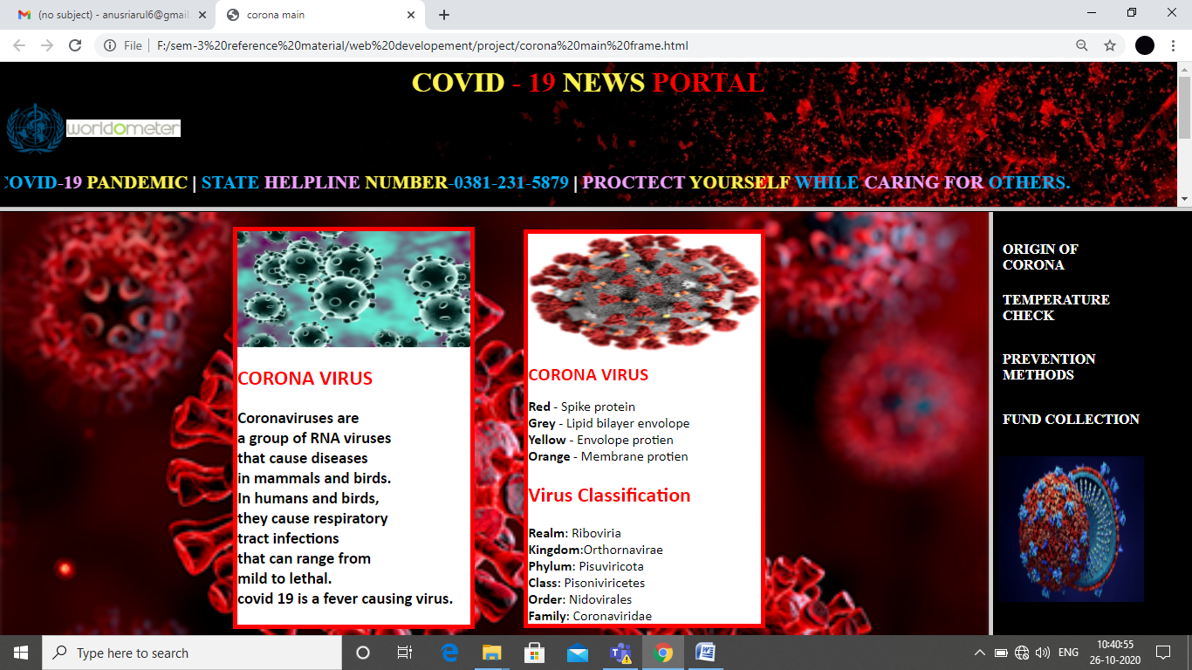

**WORLDOMETER**

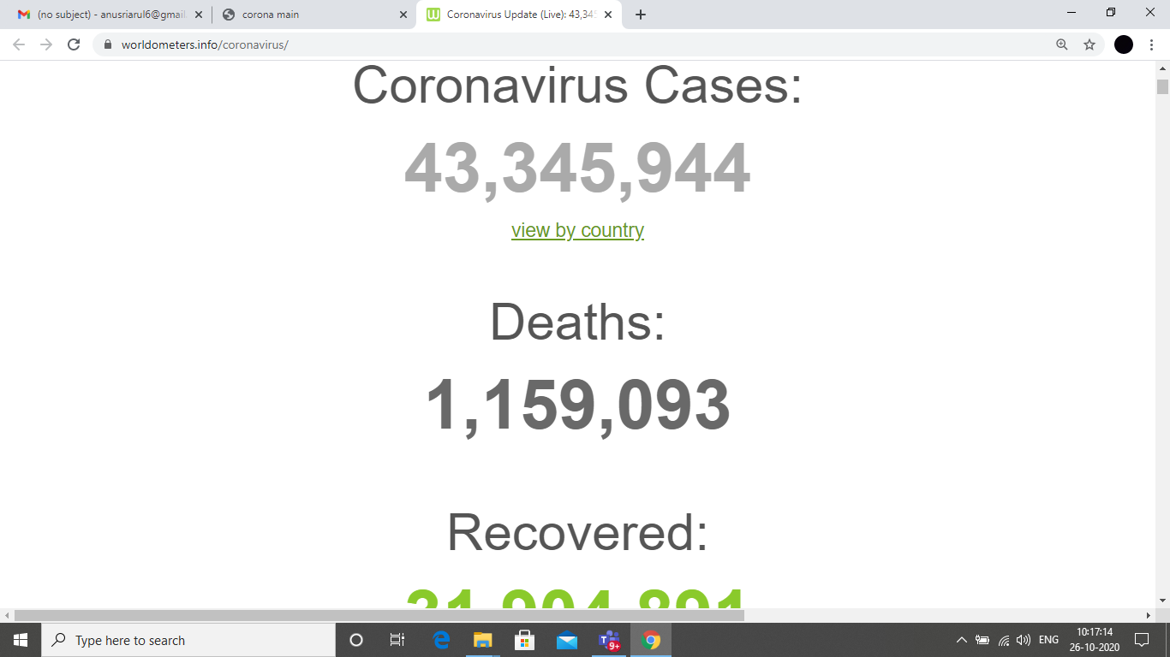

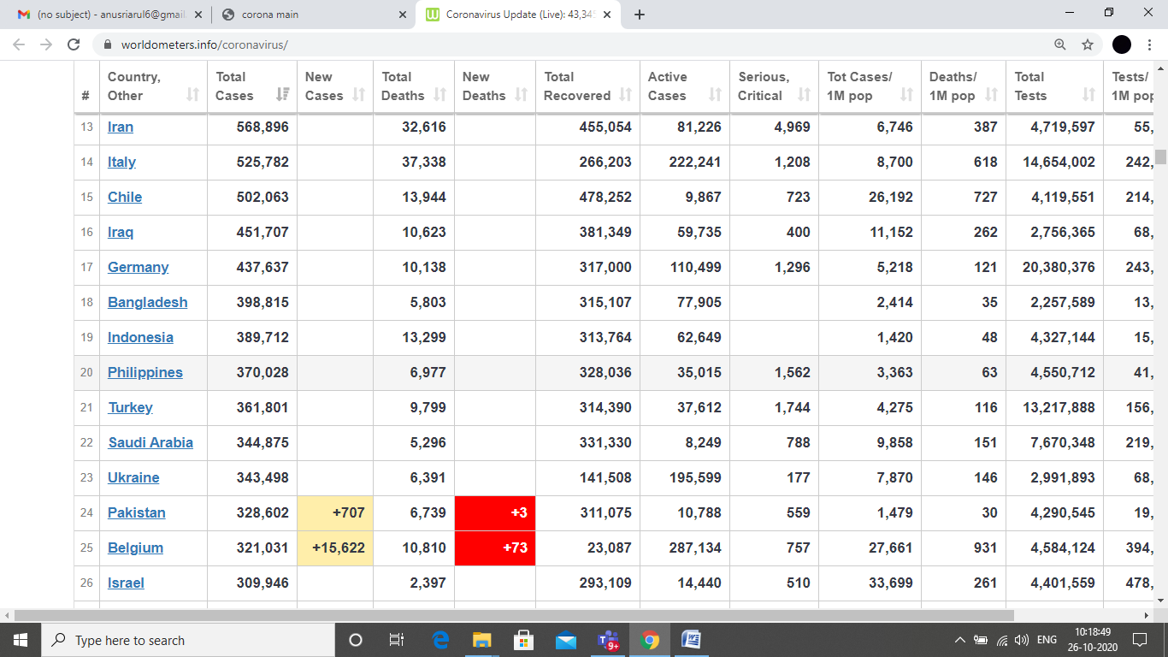

**FUND COLLECTION**

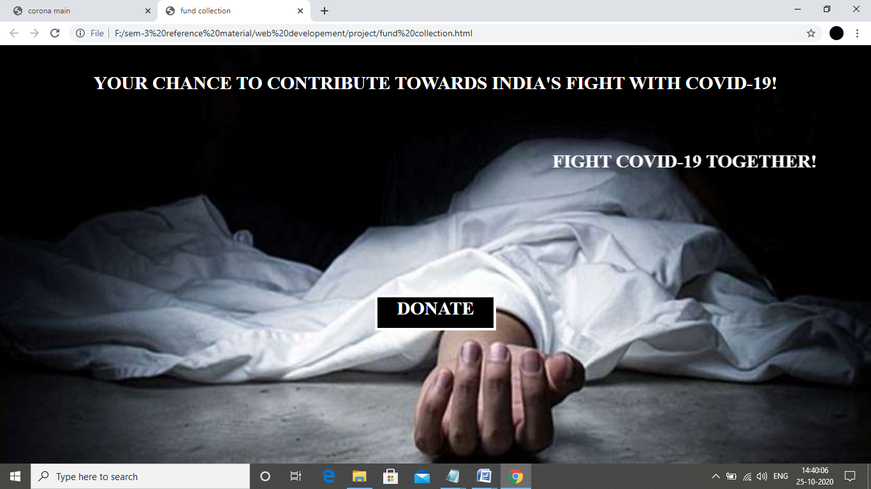

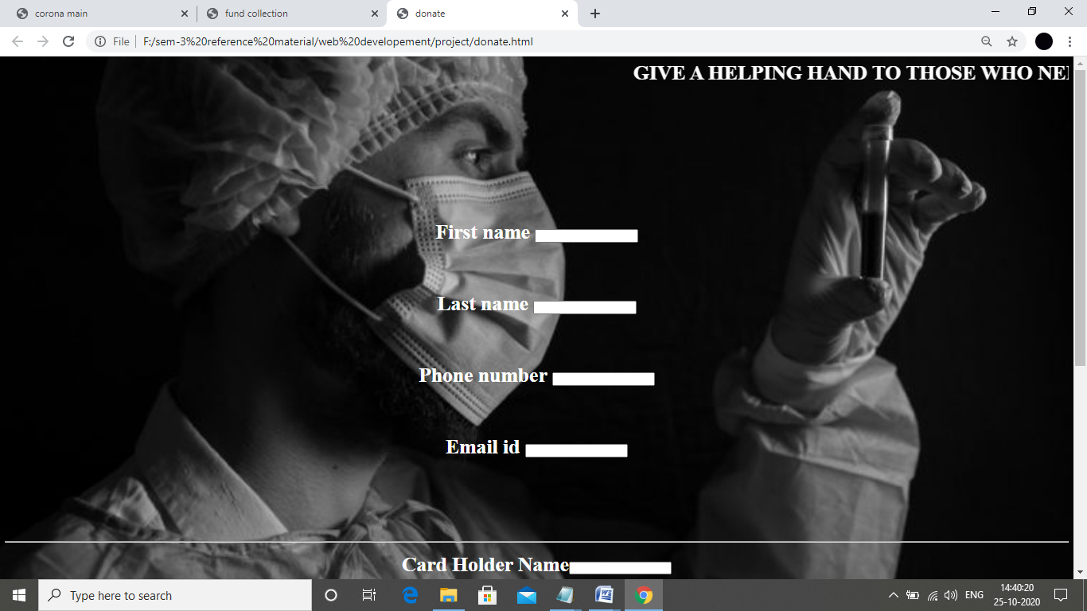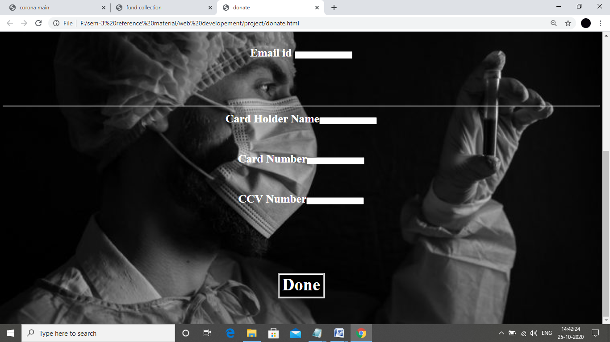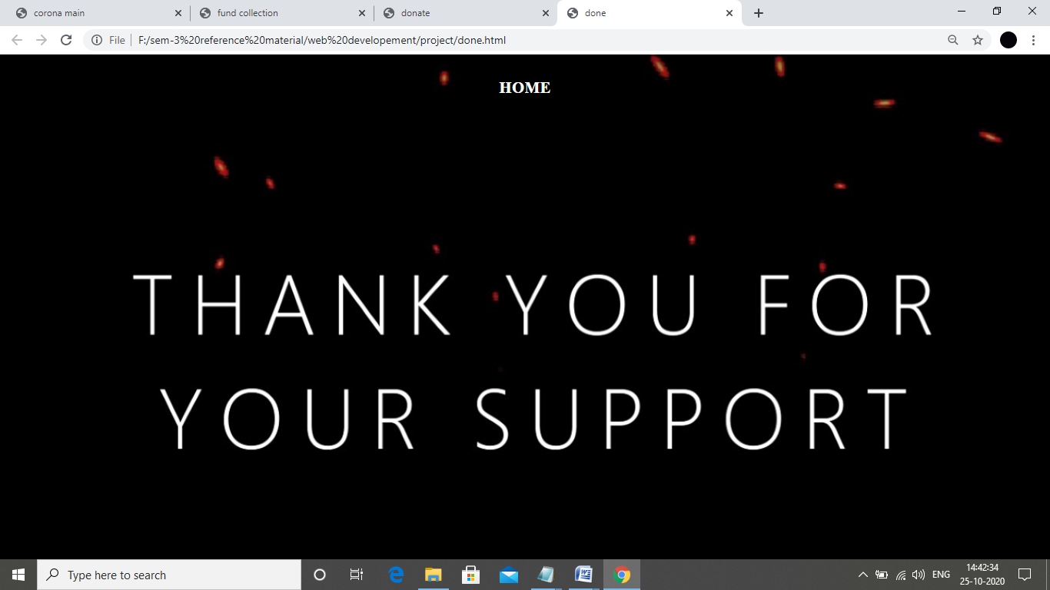

**PREVENTION METHODS**

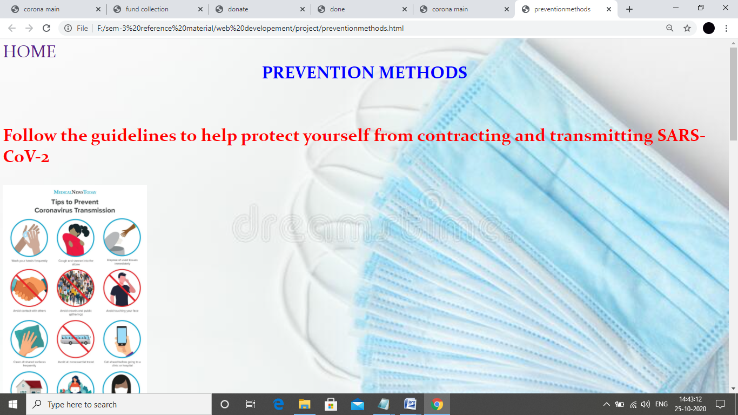

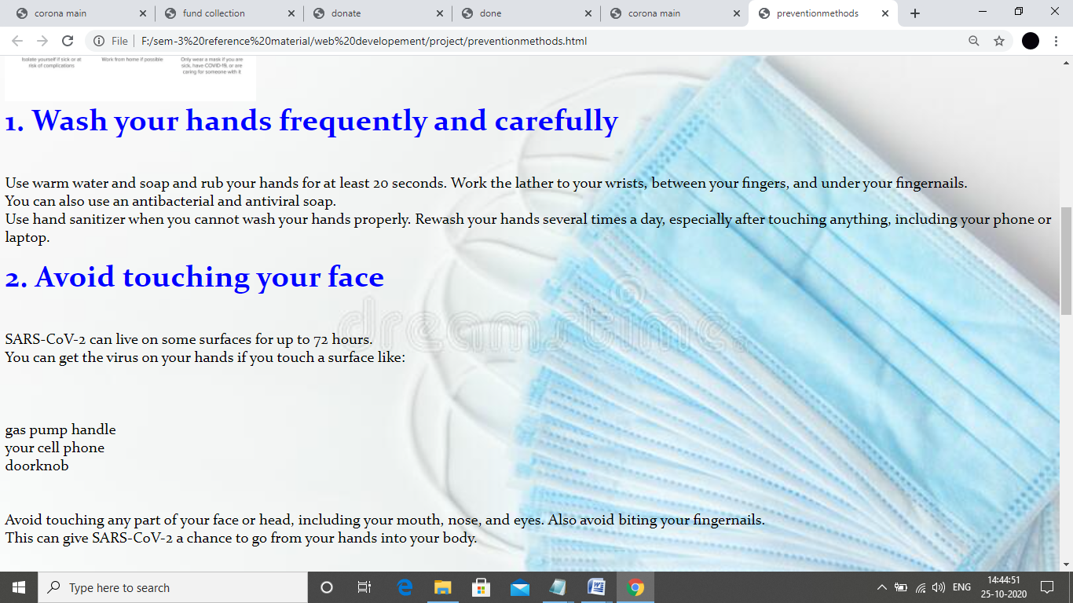

**TEMPERATURE CHECK**

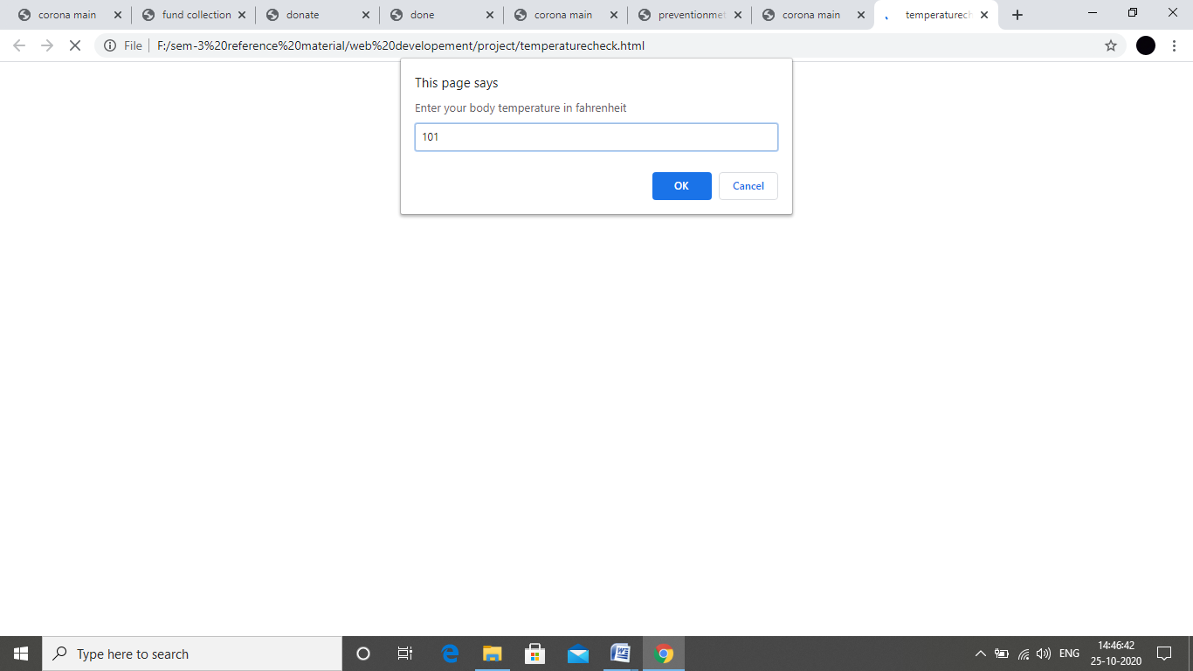

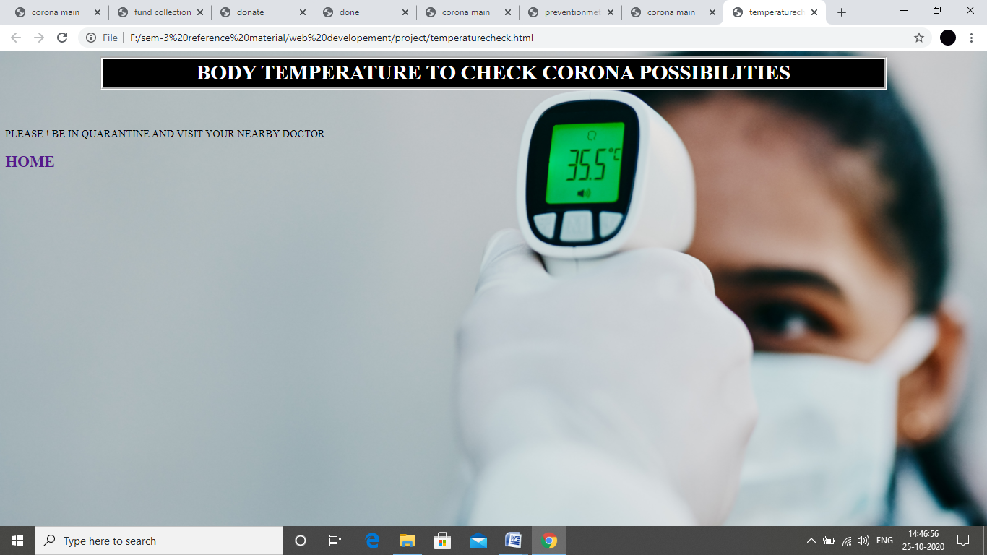

**CORONA VIRUS ORIGIN**

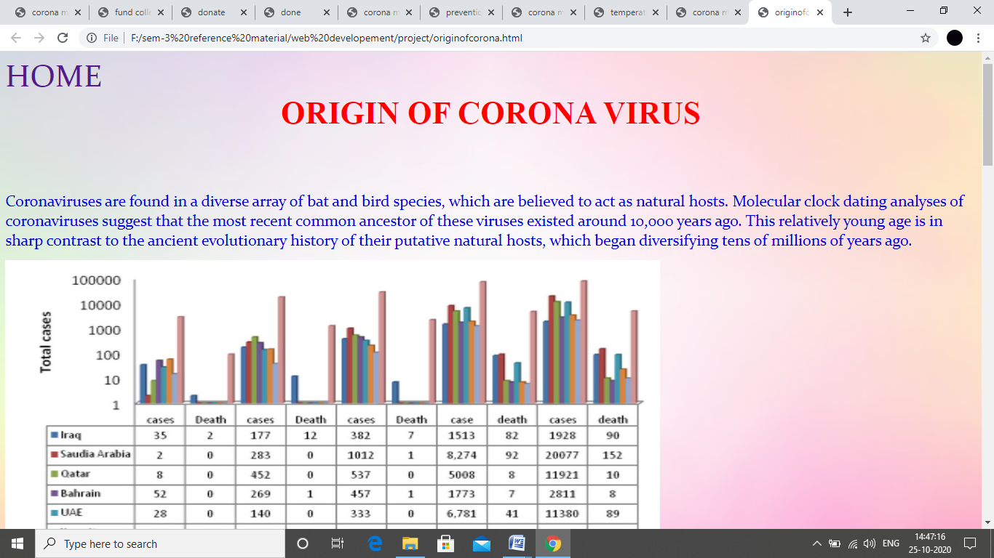

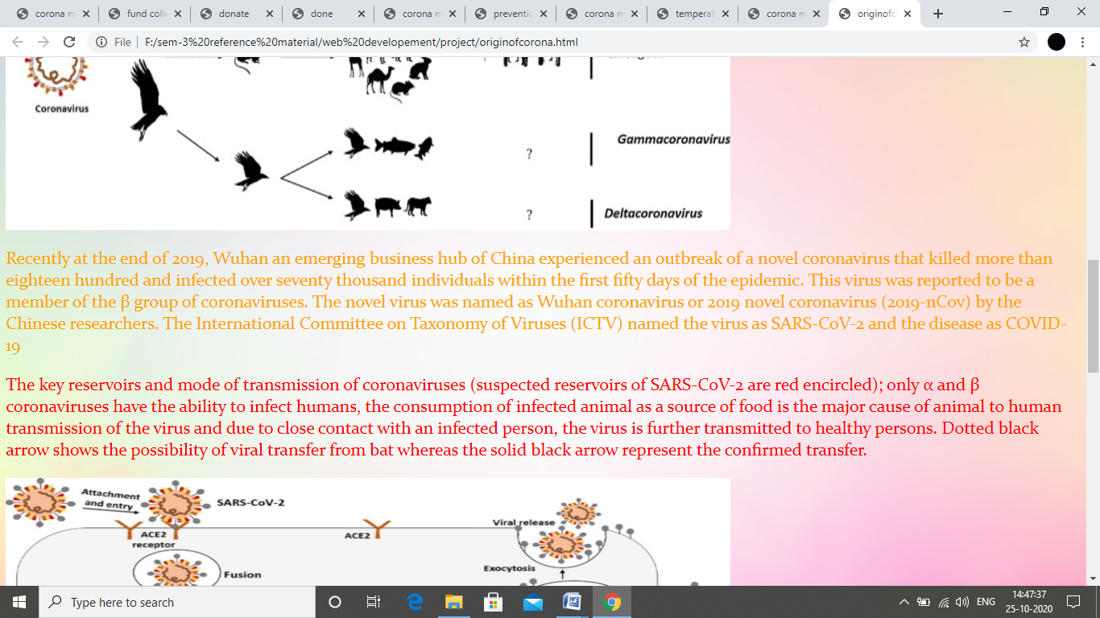

**CONCLUSION:**

By using our project people can easily find out about a particular pandemic situation. So, before people had to refer lot of books, newspaper and magazines to give knowledge about the pandemic situation but by using our project people can easily access the information from a particular webpage alone. People doesn’t want to refer different means because every single information regarding the particular virus to provided here.

***THANK YOU !***